# CHAPTER 2

# REVIEW OF THE RELATED LITERATURE AND STUDIES

This chapter presents the review of related literature and related studies underlying the framework of the study. It includes the conceptual model of the study and the operational definition of terms.

**TECHNICAL BACKGROUND**

The application will be developed using hybrid mobile app frameworks such as React Native, Flutter, or Ionic. These frameworks enable cross-platform compatibility, allowing the same codebase to be used for both Android and iOS platforms. This approach reduces development time and costs compared to building native apps for each operating system.

The system will incorporate a secure user authentication mechanism, such as two-factor authentication (2FA) or biometric verification, to ensure the privacy and security of donor and recipient data. Users will create profiles detailing their blood type, medical history, and contact information. The application will also feature a donor eligibility checker to ensure that donors meet the necessary criteria before donating The application will utilize geolocation services to help donors locate nearby blood donation centers or mobile blood drives, providing directions and estimated travel times. It will also feature a built-in messaging system to enable communication between donors, recipients, and blood bank staff.

The Blood Inventory Management system will maintain a real-time inventory of available blood types and quantities. Staff members will be able to update inventory levels, track blood usage, and set alerts for low stock levels. The application will also leverage push notifications to alert users about urgent blood needs, upcoming donation events, or changes to their appointments.

By incorporating these technologies, the mobile-based hybrid blood bank application aims to streamline the blood donation process, improve donor engagement, enhance inventory management, and facilitate effective communication between all stakeholders involved in the blood donation ecosystem.

# RELATED LITERATURE

In 2023, Li L et al., Proposed a system Donating blood without payment is a selfless act of civic duty, and the addition of gamification features to blood donation applications can improve the experience of donors, particularly young people. This study examines the features and gamification components of the mobile blood donation apps currently available. Three duplicates were found out of 801 apps during a search that was conducted in Google Play, Apple Apps store, Blackberry App World, and Windows Mobile App shop to choose 10 gamified BD apps. The findings indicate that traditional and social login are the most common forms of authentication, and that most blood donation applications do not support various languages.[1]

According to the authors, technological advancements and the widespread use of mobile devices have significantly accelerated the development of mobile applications in the health sector. Blood donation centers often experience blood shortages due to insufficient donations. Consequently, social networks frequently display urgent blood donation requests for specific blood types. Mobile applications designed for blood donation are essential in the health sector as they facilitate immediate communication between donors and blood donation centers. This prompt coordination minimizes the time required for the donation process**.** [2]

The blood is a lifesaver if there ever emerges any events of the emergency needs. The errand of the blood bank is to get the blood from the different types of people caning to donate the blood, to manage blood bundles’ database and to provide the needed blood in between of the need to the mending donation if there emerges any events of emergencies. The issue here isn’t the lacking number of the people caning to donate the blood, but finding any enthusiastic supporter/donor at the advantageous time. We have to make an arrangement of people who may help each other in between of an emergency. The android application in this project prompts the updates of the information for the supporters/donors where the chief gets the entire information about the blood bank system.

Give away/donor can then be incited into entering a man’s purposes of information, like name, email, phone number, and the blood group. At the usual time of any blood need, one can quickly check the red blood blank android application database or recuperating database planning related or explicit the blood gathering and the interface with them through android application. The blood bank android application gives away all over information of the blood bank android application focused on your region. A noteworthy number of people caning to donate the blood can be pulled into using this android application. Since about every one now carries mobile phones with them, to ensure minute region surveillance and correspondent changes. Only an enrolled individual self, with the capacity to give away the blood, can have the ability to get to the society. In this android application we are using the GPS advancements which can be used to be pursued the course to the blood bank. The customer can get the course to be accomplished using the pin for each region and they will not be asking physically, thus time can be saved. With uprising of correspondence nowadays, one needs headways upgrades to all territories, especially for prosperity space.

This report gives an android application a system which is planned to give away most information needed for the blood social circle or affair which is reliably asked for an advancing reason. The system depicts the convenience and the ease to contact with different suppliers and dejects for different blood social events. The android application acquaints on the insightful contraptions with the assurance of the arrival of a greatest possible no. Of the red blood benefactors within the country. This tackles PDAs with the android system laid by the blood bank.[3]

Medical monitoring requires instant visibility across data sources and access to dynamic analyses. However medical monitoring among patients, perform in-stream medical advice, remains a challenging problem. Blood banks suffer frequent shortage of blood due to lack of blood donations, hence blood donation requests are frequently seen on social media for patients who urgently require blood transfusion with specific blood group. Recently, worldwide efforts have been undertaken to utilize social media and smart phone applications to make the blood donation process more convenient and provide a concrete information system that allows donors and blood donation centers to communicate efficiently and coordinate with each other to minimize time and effort required for blood donation process. This paper aims at developing a Cloud medical monitoring and Web-Based Blood Donation System which will allow blood donors and patients to offer/request blood donation from blood banks. Additionally, a new method is proposed for continuous observation and communication among doctors and patients. Using IOT cloud platform, simple medical devices equipped with medical sensors can monitor health status of patients and update the electronic medical records of patients’ information. Medical experts can remotely monitor patient’s dynamic status and give prompt medical advice.

The developed Web-Based application utilizes a cloud-based hosting platform to enhance system performance and ensure high availability. A mobile application has been developed where users will be able to use as an application installed on their smart phones to help them complete blood donation process with minimum effort and time. This application helps people receive remotely medical advices and helps establish a blood donation community through social networks. This paper also presents various tools that were used to measure system performance. [4]

In the field of healthcare management, blood donation is of particular interest due to its crucial and vital importance in saving lives. In Iraq, the blood donation procedure often takes a long time for donors because it is done through an unautomated and paper-based process, only done at hospitals/medical centers for those who are willing Blood Donation. Patients who need to donate blood may have to wait to receive this service, which can lead to serious or unwanted consequences. At the same time, the blood donation process negatively affects those who want or desire to donate blood and often causes many of them to ignore the issue, unless there is an emergency situation related to blood donation. This article proposes a Mobile Blood Donor Registration System (MBRS_BD) using Firebase Cloud Messaging (FCM) to automatically manage the blood donor registration process using smartphones to simulate and facilitate convenient and minimize the time needed for this. Donors can register at any available Iraqi hospital/medical center using MBRS-BD and arrive at the exact time to complete their donation process.[5]

Blood is an essential element of human life and nothing can replace it. The World

Health Organization (WHO) recommends that countries focus on youth to achieve 100% voluntary, unpaid blood donation by 2020. Blood donation can be lifelong save for people who have lost large amounts of blood due to serious situations, obstetric and gynecological hemorrhage or surgical interventions and stem cell transplants, as well as for people with symptomatic anemia due to medical or hematological problems. Blood banks have a mission to provide adequate services and safe blood to the community. Urgent crises such as accidents require rare blood types or anemia.

The hospital needed to reach a large number of donors and there was no way to do that. This is the dilemma we want to solve with our app. Any blood pooling center that reorganizes Gail registers itself in the system so that it can receive blood supplies in case of shortages. Tools used in the project development is PBP, MYSQL and HTML. The system developed will fill the main gaps that exist in terms of connectivity and interaction between blood banks and hospitals[6].

# RELATED STUDIES

Blood donation is a vital process that saves countless lives every day. In the Philippines, the Philippine Red Cross plays a crucial role in supplying blood products to those in need. However, the current paper-based procedures used by the Red Cross can be time-consuming and inefficient, leading to delays and sluggish service. With the advent of technology, there is an opportunity to develop innovative solutions that can streamline the blood donation process, making it more efficient and effective. This study aims to explore the development of a mobile-based hybrid blood bank application for the Red Cross Muntinlupa Chapter, building upon the successes and lessons learned from previous automation efforts. The research on the development of a Blood Management System with Donor Finder for the Red Cross Laguna Chapter in 2019 showcased the potential benefits of automating blood donation processes and enhancing service delivery within the organization**.**

According to [7], apart from the numerous advantages they offer in our day-to-day existence, computers and mobile phones have grown increasingly ubiquitous in our society. The Corona pandemic and the problems it raised made internet communication—through websites and applications—essential. Many lives could be lost as a result of the difficulty in finding a reliable blood bag. Donating blood is essential for thalassemia patients, cancer patients, accident victims, and surgery patients.

Finding and visiting a blood bank is necessary in order to donate blood. Selecting the best donor in a pinch could be difficult. Recipients frequently struggle to locate the right blood donor since uncommon blood types aren't always available at all blood banks. To deal with the matter of the removal of rare blood types, poor management of blood banks, a lack of knowledge and confidence, and the difficulty of identifying a particular blood type are all contributing factors to the shortage of blood bags. The goal of this project is to create and implement a mobile application. Using a blood donation app that is linked to the central database, which aggregates and organizes data from all blood banks and donation drives, is recommended. The suggested application oversees and controls every procedure required for blood donation.[8].

According to [9], files are the main emphasis of the blood bank's current storage system. This guarantees that information regarding blood, donors, and Recipients are kept in archives and documents. Processing data and information so becomes challenging and time-consuming. of this. Physical records of all blood donor and transfusion tests are also kept. Information is therefore powerless to Human error and mistakes lead to dangers to human life. Another fundamental issue with this structure is penurious efficiency. It takes a lot of work to get blood due to the laborious process, whether it is donor or recipient information. The current blood bank's storage system primarily focuses on files, making data processing challenging and time-consuming. This system also keeps physical records of donors and transfusion tests, making it vulnerable to human error and potential dangers to life. The system also lacks efficiency, making it difficult to retrieve blood during critical moments. Additionally, information backup and security are crucial, as papers and records can be easily lost or stolen. The project aims to provide a platform with all registered blood donations data, enabling quick blood delivery. The project has been thoroughly researched on blood management systems and procedures, aiming to optimize its potential. A blood donation management system should have an information mechanism for recipients, donors, and other interested parties, and ensure transparency about blood inventory status. Identifying and addressing the shortcomings of the current system is crucial for the project's success.

According to [10] each year, millions of lives are saved by blood donation. It can assist cancer patients receiving treatment, prior to mature infants, high-risk pregnant moms, Patients with hematopoiesis requiring transfusions treatment, hurt, and possibly deadly defectsfacilitates and supports intricate medical and medical operations.Giving blood while adhering to the equity principle symbolizes a significant social movement of unity interactions and life support via volunbiased, selfless, and devoid of bias behavior. obtaining blood products and therapies fits with one of the tactics intended to achieve equity in the public health system, serving as an vital element of efficient health system.

According to study of [11], blood donation is crucial for managing and saving lives. An automated system for managing and scheduling blood donation events could be developed to improve the efficiency of this procedure. We created an integrated architecture for a blood management system in this study that includes all connected but separate web-based subsystems. As a crucial component of the integrated system, we suggest a data warehouse (DW) to keep historical blood donor data in a centralized database for processing analytically. Based on the analytical findings from the DW for a specific region for a specific time and citizen demography, the proposed system would allow the authorities to make well-informed decisions for blood donation camping. Lastly, we present a brand-new humanity-measuring system score system.

In 2018 based on the study of [12], Blood services are vital because they have the potential to save lives. Lack of a platform to arrange appointments for blood donations and blood requests causes issues like ignorance about the procedure for donating blood and requesting blood. A framework for creating an Android mobile application that will streamline blood services between blood banks, donors, and blood requesters is presented in this paper. The planned system will enable blood banks to oversee blood donations and requests, monitor up-to-date data on the state of blood services, and organize blood campaigns to encourage more people to give. Blood donors will be able to easily organize blood donation appointments or take part in blood drives thanks to the proposed smartphone application.

In 2017 based on the study of [13], when a patient requires blood, the clinic where they are admitted will use the app's "Send Request" feature to ask registered volunteers in the same or neighboring state or city to donate. In the event that a patient is admitted to a clinic, for instance, donors who reside in the Markham and Brampton areas might also receive notification. Depending on the patient's needs, the requester can notify donors as an emergency or as usual, Sometimes, procedures are planned ahead of time, and blood donations are then recorded as usual if necessary. Following the fulfillment of a request, i.e., the successful donation, the clinic might provide the prior beneficiaries with an update. "BloodRequests Feed" displays requests from other users.

The application's features are explained, and their usage requirements are examined. Using the clinic management feature of this program, blood donors nearby can be notified if a patient at the clinic requires blood. Only if the registered donor's blood type and location match the requested blood type will they be notified about blood requests. Donors who match can then visit the clinic making the request to donate blood.

In 2016 study of [14] evaluated the COVID-19 pandemic's effects on blood donors and transfusions in Nigeria in a paper published in 2016. According to the study, there was a notable decrease in blood donations and transfusions as a result of the epidemic, with a 17.1% drop in donations and a 21.7% loss in transfusions. The departments that saw the biggest drops in platelet transfusions and fresh frozen plasma were the surgery and accident and emergency departments. The necessity of bolstering blood services during public health emergencies is highlighted by this research.

According to [15], the blood donation saves lives in a variety of circumstances. They can have more energy after receiving a blood transfusion to spend with friends and family. Blood can only be given as a gift from individuals; it cannot be produced. Only six pints of blood could be donated by one individual. Thirty-three lives can be saved by one pint of blood. In comparison to other nations, the number of blood donors is extremely low. Here, we suggest a fresh and effective method for overcoming this issue. The app will ask you to enter a person's details, like name, phone number, age, weight, date of birth, blood type, address, and so on, when you simply press the donation button. When blood is urgently needed, we can find a nearby blood donor by by GPS. The software will automatically identify a donor in the area and notify them as soon as the user enters the blood type they require. If the first donor is not available, the system will look through the next person in line automatically. An One Time Password (OTP) will be sent to the donor for verification if they accept the request. a list of donors in your city or area provided by the blood donation app. The donor's information will be automatically deleted after the blood donation for the following three months.

According to [16], through the use of mobile devices and communication technology, mHealth opens up new possibilities for the provision of healthcare services. Blood donation in the medical field is a difficult procedure that takes time to locate a donor whose blood type matches the patient's. In order to provide mHealth solutions that enable the requester and donor to communicate at any time and from any location, we built an android-based blood donation application. This application's goal is to give information about the required blood and the quantity of available donors in the surrounding areas. With the help of our application, the requester can spread the word around the maintained volunteer blood donor network and simultaneously find out who is willing to donate the desired blood.

We developed requester-donor profiles in order to assess our application, and we found that it will facilitate better information access in a timely manner and enable quick action in emergency situations.

**RELATED SYSTEMS**

In order to simplify the collection, testing, storage, and distribution of blood and its components to patients in need, a blood bank system is an essential part of the healthcare infrastructure. It includes a number of procedures to guarantee the effectiveness and safety of blood transfusions, such as blood type, donor registration, infectious disease screening, inventory control, and logistics for prompt delivery to hospitals and other healthcare facilities. In order to improve the precision, traceability, and accessibility of blood products, modern blood bank systems frequently integrate cutting-edge technology, such as barcoding, automated testing apparatus, and online platforms for donor recruiting and appointment scheduling. In times of emergency, during surgeries, and during treatments for a variety of illnesses requiring blood transfusions, these devices are essential to preserving lives.

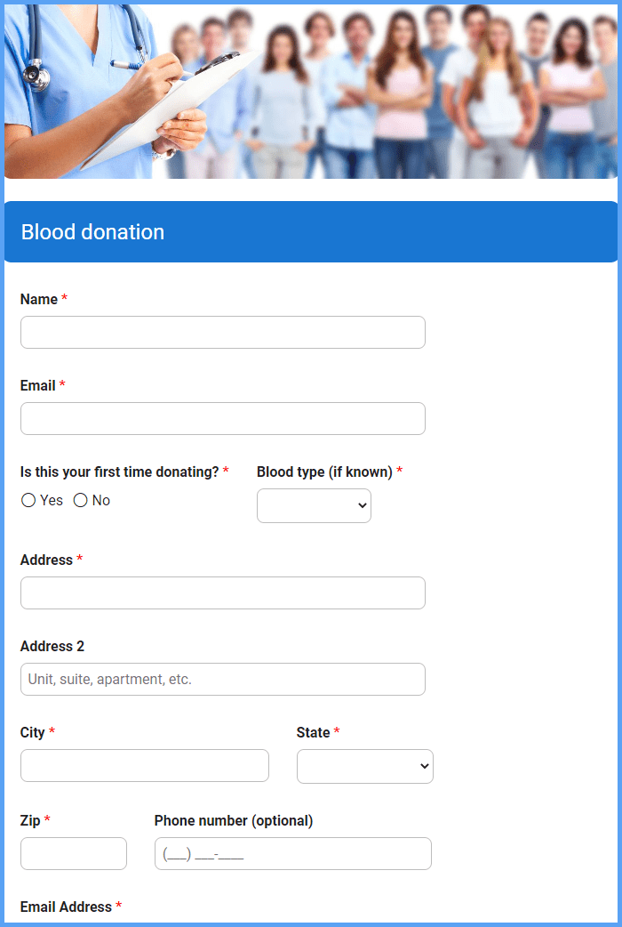

*Figure 1.* Sample Screen of System Page

Figure 1 shows the approach to registering donors and managing blood requests. By providing a user-friendly interface, donors can easily schedule appointments, track donations, and engage with educational resources. Recipients benefit from a simplified process to request specific blood types or products, enhancing efficiency during critical situations. The application's focus on real-time updates, secure data handling, and compliance with regulations ensures transparency, security, and trust among users. Overall, such an application serves as a vital tool in promoting community engagement and saving lives through efficient blood donation and distribution processes.

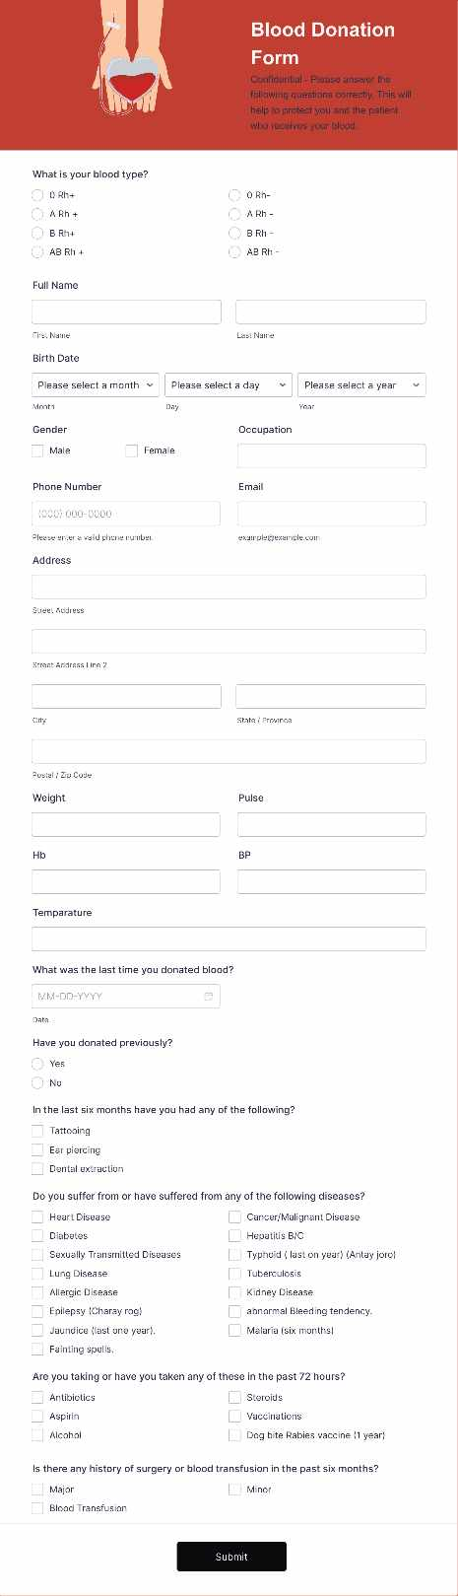Top of Form

Bottom of Form

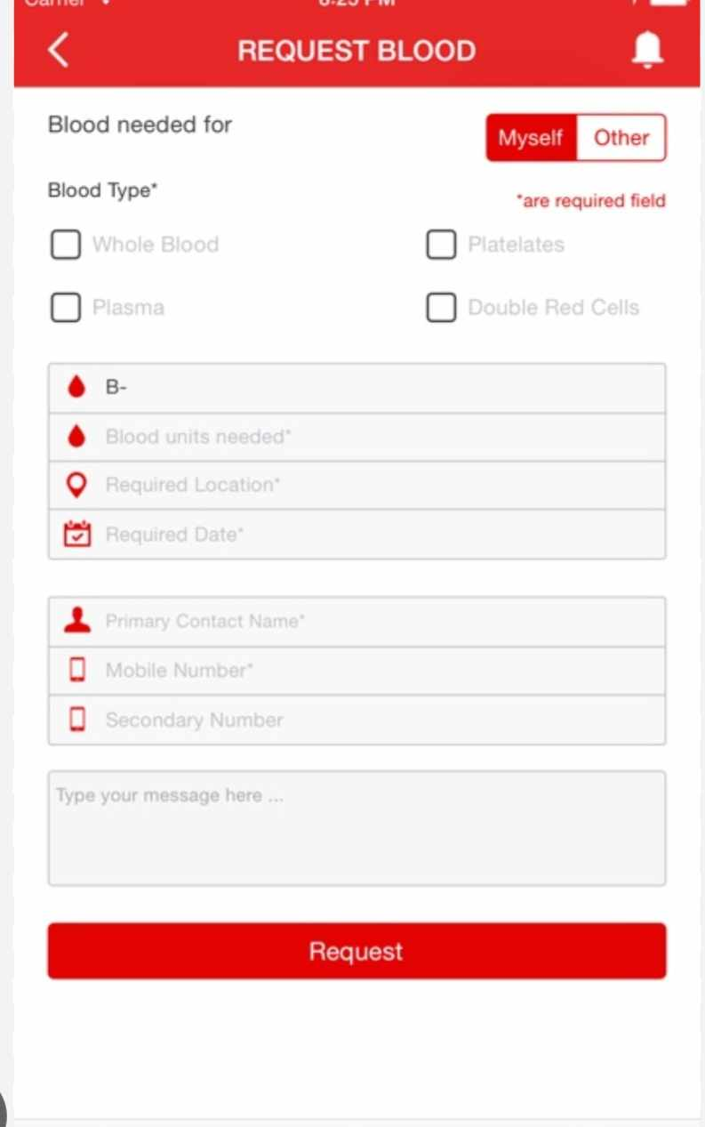

*Figure 2.* Sample Screen of System Page

Figure 2 shows the requesting blood through a blood bank application is a straightforward process that offers convenience and efficiency. Users, typically healthcare providers, can submit requests specifying the required blood type, quantity, and urgency. The application streamlines communication between healthcare facilities and blood banks, allowing for swift response times and timely access to blood products. Real-time updates enable users to track the status of their requests, ensuring transparency and accountability in the blood donation and distribution process. Overall, requesting blood through a blood bank application simplifies the process, enhances accessibility, and contributes to improved patient care.



*Figure 3.* Sample Screen of System Page

Figure 3 shows Donating blood through a blood bank application is a user-friendly process that simplifies the donation experience. Users can easily find nearby donation centers, schedule appointments, and receive notifications for upcoming drives. The application provides essential information about eligibility criteria and donation requirements, ensuring a smooth and efficient process. By leveraging technology, blood bank applications make it convenient for donors to contribute to lifesaving efforts, ultimately helping to meet the ongoing demand for blood products in healthcare settings.

**DEFINITION OF TERMS**

For clarity of presentation, the following terms are defined as used in the study.

# Operational Terms

**Blood Management System:** A system designed to automate processes related to blood donation, inventory management, donor engagement, and monitoring of blood banks within the Red Cross organization.

**Donor Finder:** A feature within the system that helps identify and engage blood donors by tracking their donation history and providing recognition for their contributions.

**Blood Donation Programs**: Organized events held in various locations such as schools, malls, city halls, and companies to encourage voluntary blood donations.

**Blood Inventory Management:** The process of maintaining real-time records of available blood stock, updating inventory levels, and setting alerts for low stock levels.

**System Evaluation:** The assessment of the developed system based on criteria such as functionality, usability, efficiency, maintainability, and portability to ensure it meets the desired objectives.

# Technical Terms

**ISO 9126:** A standard used for evaluating software quality characteristics, including functionality, usability, efficiency, maintainability, and portability.

**Primary Data:** Information collected directly from surveys and interviews to determine system requirements and features needed for system development.

**Web-Based Environment:** An online platform that allows efficient management and retrieval of data, providing access to blood stock inquiries and management features.

**PHP Programming Language:** A popular scripting language used for web development, often employed in creating dynamic web pages and web applications.

**MySQL:** A widely used open-source relational database management system (RDBMS) that stores and manages data for web-based applications.

**REFERENCES**

[1] Li L, Valero M, Keyser R, Ukuku AM, Zheng D. Mobile applications for encouraging blood donation: A systematic review and case study. Digit Health. 2023 Oct 8;9:20552076231203603. doi: 10.1177/20552076231203603. PMID: 37822963; PMCID: PMC10563464.

[2] O. Iparraguirre-Villanueva, F. Sierra-Liñan, M. Cabanillas-Carbonell, “ 2022 Location-based Mobile Application for Blood Donor Search”. https://repositorio.uwiener.edu.pe/handle/20.500.13053/6889

[3] Gupta, S. Singh, P. Kumar, “ 2019 Blood Bank Android Application Collection Centre,” http://www.ir.juit.ac.in:8080/jspui/handle/123456789/6750

[4] Moh. Nabil et al 2020 J. Phys.: Conf. Ser. 1447 012001,https://iopscience.iop.org/article/10.1088/1742-6596/1447/1/012001/meta

[5] Al-Sammarraie, et.al (2022) Mobile-base Registration System for Blood Donation (MBRS-BD). Asian Journal of Research in Computer Science, 14 (4). Pp. 36-45. ISSN 2581-8260 http://scholar.sdpublishers.info/id/eprint/22/

[6] Ocen, et.al 2022 http://196.43.171.194/handle/20.500.12283/2467

[7] Lawas, K. , Glorioso, J. & Capuno, J. (2023). Sagot Ko Dugo Mo: A Blood Management System with Donor Finder for Red Cross Laguna Chapter. Ani: Letran Calamba Research Report, 19(1), 54-55.https://www.ejournals.ph/article.php?id=1965820

[8]. M. M. Hummady, "Design Mobile Application for Blood Donation System,"2022 International Conference on Computer and Applications (ICCA), Cairo, Egypt, 2022, pp. 1-5,doi: 10.1109/ICCA56443.2022.10039544

[9] A Research Paper on “ Blood Donation Management System" by A. Clemen Teena, K. Sankar (2021)

[10] Brasil Pan-Americana da Saúde (OPAS). Dia Mundial do Doador de Sangue 2019 Sangue seguro para todos (2019)

[11] G. Maji, N. C. Debnath and S. Sen, "Data Warehouse Based Analysis with Integrated Blood Donation Management System," 2018 IEEE 16th International Conference on Industrial Informatics (INDIN), Porto, Portugal, 2018, pp. 855-860, doi: 10.1109/INDIN.2018.8471988.

[12] A. Casabuena et al., "BloodBank PH: A Framework for an Android-based Application for the Facilitation of Blood Services in the Philippines," TENCON 2018 - 2018 IEEE Region 10 Conference, Jeju, Korea (South), 2018, pp. 1637-1641, doi: 10.1109/TENCON.2018.8650395

[13] Tatikonda VK, El-Ocla H. BLOODR: blood donor and requester mobile application. Mhealth. 2017 Sep 18;3:40. doi: 10.21037/mhealth.2017.08.08. PMID: 29184892; PMCID: PMC5682362.

[14] Kulkarni, S. S., & Kulkarni, S. S. (2016). Mobile Blood Donation System for Blood Banks. International Journal of Computer Applications, 134. https://doi.org/10.5120/ijca2016909732

[15] M. R. A. Brislin, J. A. Mayan, R. A. Canessane and M. R. A. Hamlin, "Blood donation and life saver app," 2017 2nd International Conference on Communication and Electronics Systems (ICCES), Coimbatore, India, 2017, pp. 446-451, doi: 10.1109/CESYS.2017.8321318.

[16] M. Fahim, H. I. Cebe, J. Rasheed and F. Kiani, "mHealth: Blood donation application using android smartphone," 2016 Sixth International Conference on Digital Information and Communication Technology and its Applications (DICTAP), Konya, Turkey, 2016, pp. 35-38, doi:10.1109/DICTAP.2016.7543997.